LAPORAN

WORKSHOP SISTEM INFORMASI
WEB SERVER (TIF330805)

SEMESTER 3



ACARA 9

NAMA:
MUHAMMAD AFIF RAMDHANI

NIM:
E41250223

PROGRAM STUDI DILUAR KAMPUS UTAMA (PSDKU)
TEKNIK INFORMATIKA KAB. NGANJUK
JURUSAN TEKNOLOGI INFORMASI
POLITEKNIK NEGERI JEMBER
TAHUN 2026

BAB 1 PENDAHULUAN

1.1 Judul Tugas

1.2 Tujuan Tugas

1.3 Dasar Teori
.
.

BAB 2 PEMBAHASAN

2.1 Alat dan Bahan
- Laptop/PC
- Web Browser
- Visual Studio Code
- XAMPP/Laragon
- PHP
- HTML, CSS, Bootstrap
- Modul Praktikum

2.2 Langkah-Langkah dan Hasil
- Pastikan isi app/Core/Database.php masih ada class singleton dengan public static function getInstance(): PDO
public static function getInstance(): PDO
{
if (self::$instance === null) {
$host = 'localhost';
$dbname = 'si_akademik';
$username = 'root';
$password = '';

try {
self::$instance = new PDO(
"mysql:host=$host;dbname=$dbname;charset=utf8mb4",
$username,
$password
);
self::$instance->setAttribute(PDO::ATTR_ERRMODE, PDO::ERRMODE_EXCEPTION);
} catch (PDOException $e) {
die("Koneksi database gagal: " . $e->getMessage());
}
}

return self::$instance;
}

- Ganti isi dari app/Models/Mahasiswa.php
<?php

namespace App\Models;

use InvalidArgumentException;

class Mahasiswa
{
private ?int $id = null;
private string $nim = '';
private string $nama = '';
private ?int $prodiId = null;
private ?string $email = null;
private ?string $namaProdi = null;

public static function fromArray(array $row): self
{
$mahasiswa = new self();
$mahasiswa->id = isset($row['id']) ? (int) $row['id'] : null;
$mahasiswa->nim = (string) ($row['nim'] ?? '');
$mahasiswa->nama = (string) ($row['nama'] ?? '');
$mahasiswa->prodiId = isset($row['prodi_id']) ? (int) $row['prodi_id'] : null;
$mahasiswa->email = isset($row['email']) ? (string) $row['email'] : null;
$mahasiswa->namaProdi = isset($row['nama_prodi']) ? (string) $row['nama_prodi'] : null;

return $mahasiswa;
}

public function getId(): ?int
{
return $this->id;
}

public function getNim(): string
{
return $this->nim;
}

public function getNama(): string
{
return $this->nama;
}

public function getProdiId(): ?int
{
return $this->prodiId;
}

public function getEmail(): ?string
{
return $this->email;
}

public function getNamaProdi(): ?string
{
return $this->namaProdi;
}

public function setId(?int $id): void
{
$this->id = $id;
}

public function setNim(string $nim): void
{
$nim = trim($nim);

if ($nim === '') {
throw new InvalidArgumentException('NIM tidak boleh kosong.');
}
if (!ctype_digit($nim)) {
throw new InvalidArgumentException('NIM harus berupa angka.');
}
if (strlen($nim) > 20) {
throw new InvalidArgumentException('NIM maksimal 20 digit.');
}

$this->nim = $nim;
}

public function setNama(string $nama): void
{
$nama = trim($nama);

if ($nama === '') {
throw new InvalidArgumentException('Nama tidak boleh kosong.');
}
if (mb_strlen($nama) > 100) {
throw new InvalidArgumentException('Nama maksimal 100 karakter.');
}

$this->nama = $nama;
}

public function setProdiId(?int $prodiId): void
{
if ($prodiId !== null && $prodiId <= 0) {
throw new InvalidArgumentException('Program studi tidak valid.');
}

$this->prodiId = $prodiId;
}

public function setEmail(?string $email): void
{
$email = $email === null ? '' : trim($email);

if ($email === '') {
$this->email = null;
return;
}
if (!filter_var($email, FILTER_VALIDATE_EMAIL)) {
throw new InvalidArgumentException('Format email tidak valid.');
}
if (mb_strlen($email) > 100) {
throw new InvalidArgumentException('Email maksimal 100 karakter.');
}

$this->email = $email;
}

public function setNamaProdi(?string $namaProdi): void
{
$this->namaProdi = $namaProdi;
}
}

- Buat folder Repository dan tambahkan file MahasiswaRepository.php
Setelah itu masukkan kode progam
<?php

namespace App\Repositories;

require_once __DIR__ . '/../Models/Mahasiswa.php';

use App\Models\Mahasiswa;
use PDO;

class MahasiswaRepository
{
private const SELECT_BASE = "SELECT mahasiswa.*, prodi.nama_prodi
FROM mahasiswa
LEFT JOIN prodi ON mahasiswa.prodi_id = prodi.id";

private PDO $pdo;

// Inject the shared database connection; this class does not create its own connection.
public function __construct(PDO $pdo)
{
$this->pdo = $pdo;
}

public function all(): array
{
$stmt = $this->pdo->prepare(self::SELECT_BASE . " ORDER BY mahasiswa.nama ASC");
$stmt->execute();

return $this->hydrateAll($stmt->fetchAll(PDO::FETCH_ASSOC));
}

public function search(string $keyword): array
{
$sql = self::SELECT_BASE . "
WHERE mahasiswa.nama LIKE :name_keyword
OR mahasiswa.nim LIKE :nim_keyword
ORDER BY mahasiswa.nama ASC";

$stmt = $this->pdo->prepare($sql);
$pattern = '%' . $keyword . '%';
$stmt->execute([
'name_keyword' => $pattern,
'nim_keyword' => $pattern,
]);

return $this->hydrateAll($stmt->fetchAll(PDO::FETCH_ASSOC));
}

public function find(int $id): ?Mahasiswa
{
$stmt = $this->pdo->prepare(self::SELECT_BASE . " WHERE mahasiswa.id = :id");
$stmt->execute(['id' => $id]);

$row = $stmt->fetch(PDO::FETCH_ASSOC);

return $row ? Mahasiswa::fromArray($row) : null;
}

public function create(Mahasiswa $mahasiswa): bool
{
$stmt = $this->pdo->prepare(
"INSERT INTO mahasiswa (nim, nama, prodi_id, email)
VALUES (:nim, :nama, :prodi_id, :email)"
);

return $stmt->execute([
'nim' => $mahasiswa->getNim(),
'nama' => $mahasiswa->getNama(),
'prodi_id' => $mahasiswa->getProdiId(),
'email' => $mahasiswa->getEmail(),
]);
}

public function update(Mahasiswa $mahasiswa): bool
{
$stmt = $this->pdo->prepare(
"UPDATE mahasiswa
SET nim = :nim, nama = :nama, prodi_id = :prodi_id, email = :email
WHERE id = :id"
);

return $stmt->execute([
'id' => $mahasiswa->getId(),
'nim' => $mahasiswa->getNim(),
'nama' => $mahasiswa->getNama(),
'prodi_id' => $mahasiswa->getProdiId(),
'email' => $mahasiswa->getEmail(),
]);
}

public function delete(int $id): bool
{
$stmt = $this->pdo->prepare("DELETE FROM mahasiswa WHERE id = :id");

return $stmt->execute(['id' => $id]);
}

private function hydrateAll(array $rows): array
{
return array_map(
static fn (array $row): Mahasiswa => Mahasiswa::fromArray($row),
$rows
);
}
}

- Ganti app/Controllers/MahasiswaController.php
Masukkan kode program
<?php

namespace App\Controllers;

require_once __DIR__ . '/../Models/Mahasiswa.php';
require_once __DIR__ . '/../Models/Prodi.php';
require_once __DIR__ . '/../Repositories/MahasiswaRepository.php';

use App\Models\Mahasiswa;
use App\Models\Prodi;
use App\Repositories\MahasiswaRepository;
use InvalidArgumentException;

class MahasiswaController
{
private MahasiswaRepository $repo;

// The repository is supplied by the front controller instead of created here.
public function __construct(MahasiswaRepository $repo)
{
$this->repo = $repo;
}

public function index(): void
{
$keyword = trim($_GET['keyword'] ?? '');
$mahasiswa = $keyword !== ''
? $this->repo->search($keyword)
: $this->repo->all();

require __DIR__ . '/../Views/Mahasiswa/index.php';
}

public function create(): void
{
$prodi = $this->prodiList();

require __DIR__ . '/../Views/Mahasiswa/create.php';
}

public function store(): void
{
$mahasiswa = new Mahasiswa();

try {
$this->fillFromRequest($mahasiswa);
$this->repo->create($mahasiswa);
} catch (InvalidArgumentException $exception) {
// Keep submitted values so the user can correct only the invalid field.
$error = $exception->getMessage();
$old = $_POST;
$prodi = $this->prodiList();

require __DIR__ . '/../Views/Mahasiswa/create.php';
return;
}

header('Location: /si-akademik/public/mahasiswa');
exit;
}

public function edit($id): void
{
$mahasiswa = $this->repo->find((int) $id);

if ($mahasiswa === null) {
http_response_code(404);
echo 'Data mahasiswa tidak ditemukan';
return;
}

$prodi = $this->prodiList();

require __DIR__ . '/../Views/Mahasiswa/edit.php';
}

public function update($id): void
{
$mahasiswa = $this->repo->find((int) $id);

if ($mahasiswa === null) {
http_response_code(404);
echo 'Data mahasiswa tidak ditemukan';
return;
}

try {
$this->fillFromRequest($mahasiswa);
$this->repo->update($mahasiswa);
} catch (InvalidArgumentException $exception) {
// Re-render with the submitted values and validation message.
$error = $exception->getMessage();
$old = $_POST;
$prodi = $this->prodiList();

require __DIR__ . '/../Views/Mahasiswa/edit.php';
return;
}

header('Location: /si-akademik/public/mahasiswa');
exit;
}

public function destroy($id): void
{
$this->repo->delete((int) $id);

header('Location: /si-akademik/public/mahasiswa');
exit;
}

private function fillFromRequest(Mahasiswa $mahasiswa): void
{
$mahasiswa->setNim($_POST['nim'] ?? '');
$mahasiswa->setNama($_POST['nama'] ?? '');
$mahasiswa->setProdiId((int) ($_POST['prodi_id'] ?? 0));
$mahasiswa->setEmail($_POST['email'] ?? null);
}

private function prodiList(): array
{
return (new Prodi())->all();
}
}

- Edit sebagian public/index.php
Tambahakan require_once
require_once __DIR__ . '/../app/Repositories/MahasiswaRepository.php';

Tambahkan dua use
use App\Core\Database;
use App\Repositories\MahasiswaRepository;

Ganti bagian paling bawah
$controllerClass = "App\\Controllers\\$controllerName";
$controller = new $controllerClass();

$controller->$action(...$params);

Dengan kode berikut:
$controllerClass = "App\\Controllers\\$controllerName";

// Compose the mahasiswa dependencies here so controllers stay free of connection setup.
if ($controllerName === 'MahasiswaController') {
$controller = new $controllerClass(
new MahasiswaRepository(Database::getInstance())
);
} else {
$controller = new $controllerClass();
}

$controller->$action(...$params);
- Edit View Mahasiswa
Controller sekarang mengirim object ke view, jadi $mhs['nim'] harus menjadi $mhs->getNim().

Edit sebagian app/Views/Mahasiswa/index.php
Ganti hanya blok <tr> di dalam foreach ($mahasiswa as $index => $mhs)

dengan:
<tr>
<td><?= htmlspecialchars((string) ($index + 1)) ?></td>
<td><?= htmlspecialchars($mhs->getNim()) ?></td>
<td><?= htmlspecialchars($mhs->getNama()) ?></td>
<td><?= htmlspecialchars($mhs->getNamaProdi() ?? '-') ?></td>
<td><?= htmlspecialchars($mhs->getEmail() ?? '-') ?></td>
<td>
<a href="/si-akademik/public/mahasiswa/<?= htmlspecialchars((string) $mhs->getId()) ?>/edit" class="btn btn-sm btn-warning">
Edit
</a>

<form method="POST" action="/si-akademik/public/mahasiswa/<?= htmlspecialchars((string) $mhs->getId()) ?>/delete"
class="d-inline" onsubmit="return confirm('Yakin ingin menghapus data ini?');">
<button type="submit" class="btn btn-sm btn-danger">
Hapus
</button>
</form>
</td>
</tr>

Ganti isi dari app/Views/Mahasiswa/create.php
<!DOCTYPE html>
<html lang="id">

<head>
<meta charset="UTF-8">
<meta name="viewport" content="width=device-width, initial-scale=1.0">
<title>Tambah Mahasiswa</title>
<link href="https://cdn.jsdelivr.net/npm/bootstrap@5.3.3/dist/css/bootstrap.min.css" rel="stylesheet">
</head>

<body>
<div class="container mt-5">
<h2 class="mb-4">Tambah Mahasiswa</h2>

<a href="/si-akademik/public/mahasiswa" class="btn btn-secondary btn-sm mb-3">
&laquo; Kembali
</a>

<?php if (!empty($error)): ?>
<div class="alert alert-danger"><?= htmlspecialchars($error) ?></div>
<?php endif; ?>

<form method="POST" action="/si-akademik/public/mahasiswa/store">
<div class="mb-3">
<label class="form-label">NIM</label>
<input type="text" name="nim" class="form-control"
value="<?= htmlspecialchars((string) ($old['nim'] ?? '')) ?>" required>
</div>

<div class="mb-3">
<label class="form-label">Nama</label>
<input type="text" name="nama" class="form-control"
value="<?= htmlspecialchars((string) ($old['nama'] ?? '')) ?>" required>
</div>

<div class="mb-3">
<label class="form-label">Program Studi</label>
<select name="prodi_id" class="form-select" required>
<option value="" disabled <?= empty($old['prodi_id']) ? 'selected' : '' ?>>
-- Pilih Prodi --
</option>
<?php foreach ($prodi as $p): ?>
<option value="<?= htmlspecialchars((string) $p['id']) ?>"
<?= ((int) ($old['prodi_id'] ?? 0) === (int) $p['id']) ? 'selected' : '' ?>>
<?= htmlspecialchars($p['nama_prodi']) ?>
</option>
<?php endforeach; ?>
</select>
</div>

<div class="mb-3">
<label class="form-label">Email</label>
<input type="email" name="email" class="form-control"
value="<?= htmlspecialchars((string) ($old['email'] ?? '')) ?>" required>
</div>

<button type="submit" class="btn btn-dark">Simpan</button>
</form>
</div>
</body>

</html>

Ganti isi dari app/Views/Mahasiswa/edit.php
<?php
// Prefer submitted values after validation errors; otherwise use the entity values.
$nimValue = $old['nim'] ?? $mahasiswa->getNim();
$namaValue = $old['nama'] ?? $mahasiswa->getNama();
$prodiValue = (int) ($old['prodi_id'] ?? $mahasiswa->getProdiId());
$emailValue = $old['email'] ?? $mahasiswa->getEmail() ?? '';
?>
<!DOCTYPE html>
<html lang="id">

<head>
<meta charset="UTF-8">
<meta name="viewport" content="width=device-width, initial-scale=1.0">
<title>Edit Mahasiswa</title>
<link href="https://cdn.jsdelivr.net/npm/bootstrap@5.3.3/dist/css/bootstrap.min.css" rel="stylesheet">
</head>

<body>
<div class="container mt-5">
<h2 class="mb-4">Edit Mahasiswa</h2>

<a href="/si-akademik/public/mahasiswa" class="btn btn-secondary btn-sm mb-3">
&laquo; Kembali
</a>

<?php if (!empty($error)): ?>
<div class="alert alert-danger"><?= htmlspecialchars($error) ?></div>
<?php endif; ?>

<form method="POST"
action="/si-akademik/public/mahasiswa/<?= htmlspecialchars((string) $mahasiswa->getId()) ?>/update">
<div class="mb-3">
<label class="form-label">NIM</label>
<input type="text" name="nim" class="form-control"
value="<?= htmlspecialchars((string) $nimValue) ?>" required>
</div>

<div class="mb-3">
<label class="form-label">Nama</label>
<input type="text" name="nama" class="form-control"
value="<?= htmlspecialchars((string) $namaValue) ?>" required>
</div>

<div class="mb-3">
<label class="form-label">Program Studi</label>
<select name="prodi_id" class="form-select" required>
<?php foreach ($prodi as $p): ?>
<option value="<?= htmlspecialchars((string) $p['id']) ?>"
<?= ((int) $p['id'] === $prodiValue) ? 'selected' : '' ?>>
<?= htmlspecialchars($p['nama_prodi']) ?>
</option>
<?php endforeach; ?>
</select>
</div>

<div class="mb-3">
<label class="form-label">Email</label>
<input type="email" name="email" class="form-control"
value="<?= htmlspecialchars((string) $emailValue) ?>" required>
</div>

<button type="submit" class="btn btn-dark">Update</button>
</form>
</div>
</body>

</html>

- Pengujian
Buka Xampp dan nyalakan Apache dan MySQL
Buka http://localhost/si-akademik/public/mahasiswa jangan lupa login terlebih dahulu dengan username admin, dan password admin123
Tampil: /mahasiswa menampilkan daftar dengan nama prodi, Email - untuk yang kosong.

Hasil
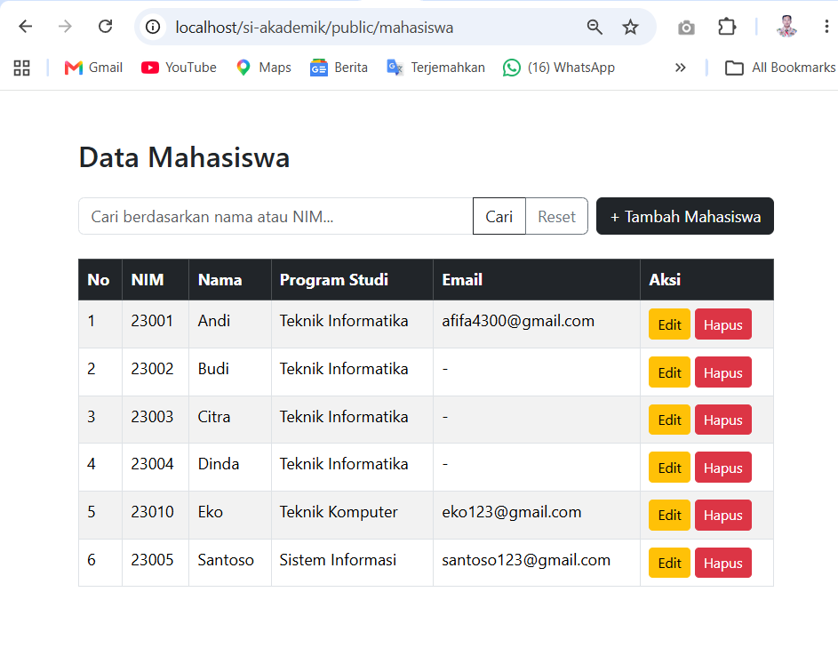
Search: cari budi atau sebagian NIM, lalu klik Reset.
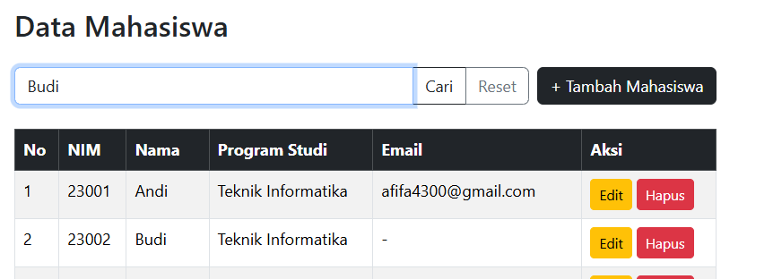

Klik reset
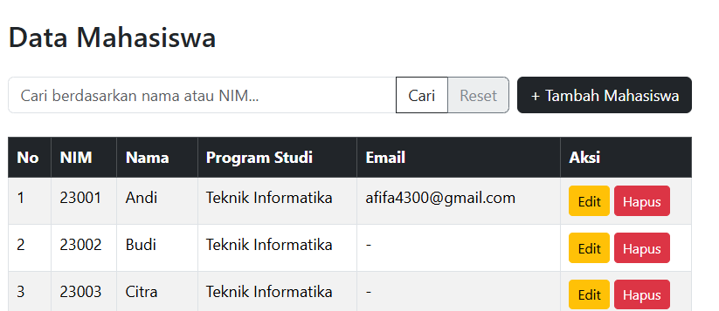

Tambah dengan data benar, harus muncul di daftar.
Klik tambah mahasiswa
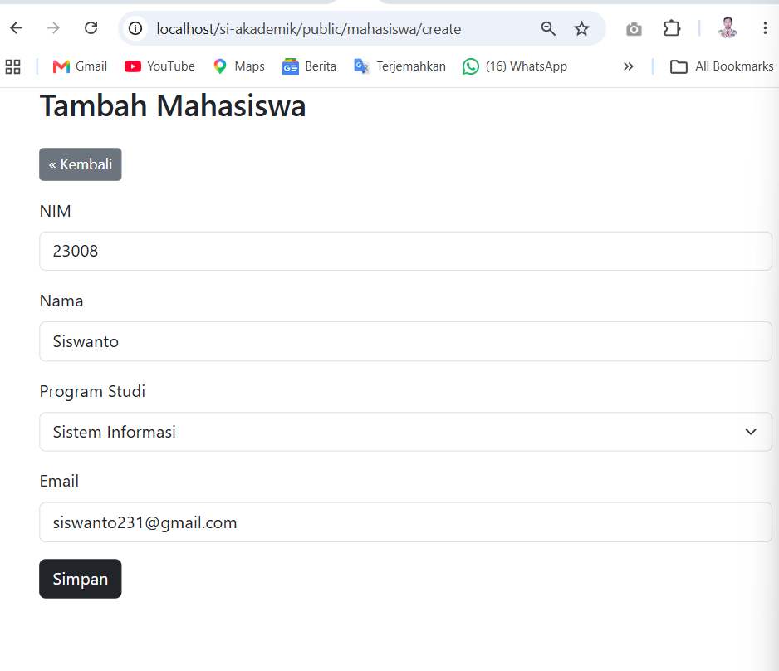

Klik simpan

Data tambahan masuk

Ubah: edit satu data, pastikan tersimpan.
Klik edit pada salah satu data

Ubah program studi menjadi teknik informatika
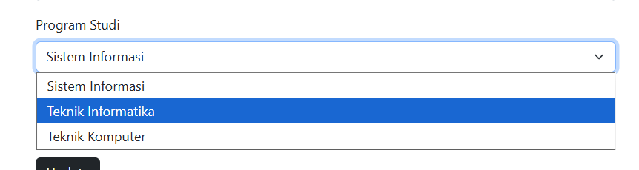

Klik update
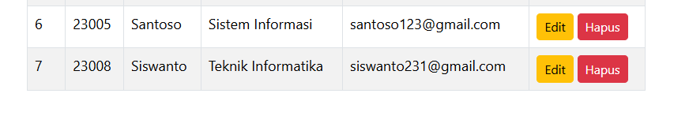

Hapus data
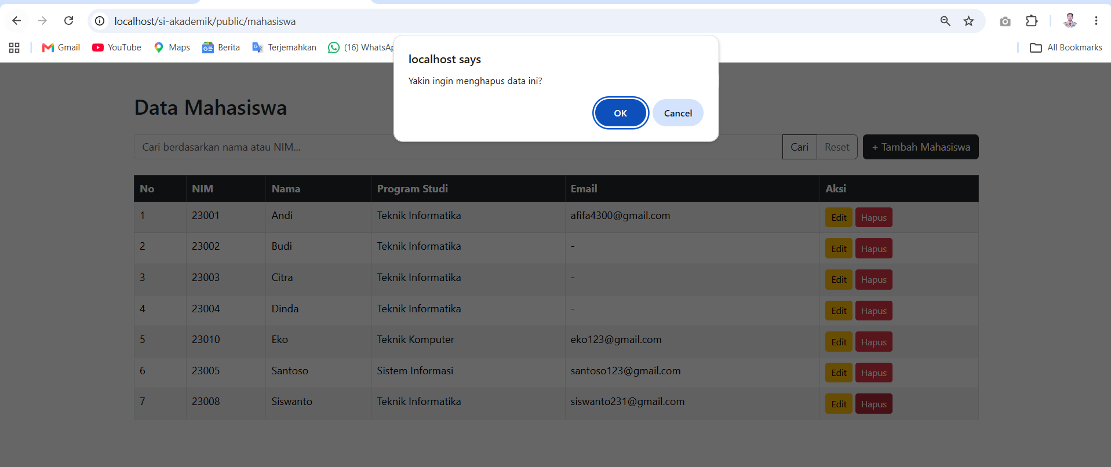
Klik hapus pada data yang ingin dihapus. Setelah itu muncul notifikasi klik ok

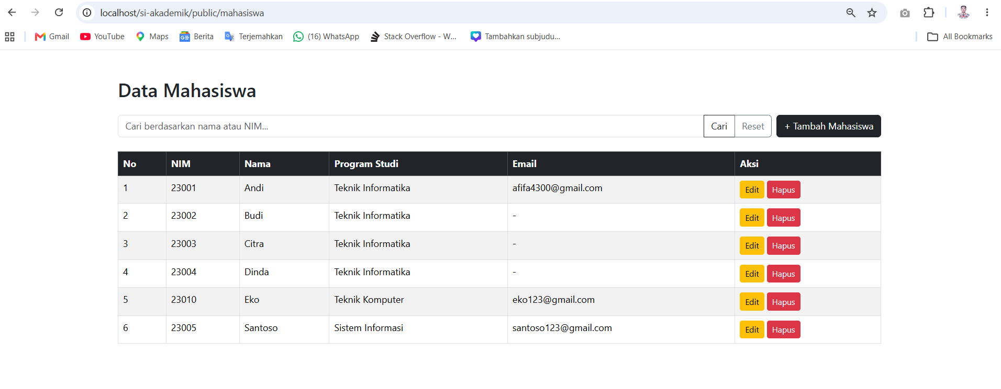
Data berhasil terhapus

BAB 3 KESIMPULAN

